**Project Name**: STree

**Problem statement**: Ecology, Environment, Climate Change and Disaster Management

**Problem**: Every year the plantation is being done in many parts of Odisha. Many saplings planted with so much enthusiasm and fanfare on different events die an untimely death due to lack of care and maintenance.

**Statement**: Citizens are showing more significant interest in the planting of trees due to the increase in awareness on environment among the people. Further, more and more individuals and institutions are coming forward for tree planting. In many functions, planting of a tree has become an indispensable part. It is quite encouraging to see that, especially during rainy season, Government or non-Government organizations, individuals and institutions go for the planting of trees with much enthusiasm and fanfare. Government organizations also distribute sapling free or at nominal cost to individuals and institutions to encourage tree planting. In the process, millions of trees are planted every year.

However, many saplings planted with so much enthusiasm and fanfare die an untimely death due to lack of care and support. It needs a little attention and protection against grazing, dry condition, and hazards of other biotic and abiotic factors. Saplings raised by the nurseryman with lot of care and skill in picking the best quality seed, its proper treatment for better germination, adequate mixture of soil and manure, watering and weeding for six months or even prolonged period for two to three years in case of tall saplings, conditioning of plants to withstand adversity of nature etc. All these labour and time is wasted when the seedlings die due to lack of care.

Planting a tree is just the beginning. It had to be taken care of and nurtured as a kid. In this age of GIS, to watch the trees we plant, we have to locate it in Google map and create a database with Geospatial reference. Thereby we can identify our plant and know about its present condition. This data has to be accessible through a simple Smartphone application by all citizens. A suitable App or other solutions need to be developed to Geo-Tag the trees and have a database of such plantations with Geospatial reference.

**Solution expected**:

Track the trees we plant.

Locate it on the Google map.

Create a database of such plants/trees with geo-spatial reference.

Locate the plant/tree and know the present condition.

Stakeholders: Forest Department, Other Government Departments, International institutions, non-Governmental organizations.

**Solution**: **STree** is an IoT based project pertaining to smart irrigation system. The project deals in tracking the location of trees/plantation areas, locating them on Google Map, creating a database with geospatial references and providing their present condition like soil water level, air humidity and temperature in the surrounding which will save plants from getting undernourished and eventual death.

**Software**: A web based application is developed in which the user can sign up using her/her mobile number and get an OTP verification code after which he/she will get their location pointed out on Google Map. The user has to click on that location and the co-ordinates of the location will automatically get recorded in the database.

**Hardware**: A setup consisting of soil moisture sensor, DHT sensor (Digital Temperature and Humidity) is to be setup in the plantation area. The soil moisture sensor monitors the soil moisture content of the soil. The DHT sensor monitors the air humidity and temperature. The most important component of the setup is the Node mcu based on ESP8266 Wifi module. It is a low cost chip which provides internet gateway for IoT. The sensor data get updated in the data base automatically every hour. An automatic sprinkler system is installed in the plantation area. It fetches the soil moisture value from the data base every 12 hours or 24 hours as per the requirement and if the soil moisture level is below a certain threshold, it gets ON. Every plantation area is marked by a marker on Google Map. The user can click on any of these markers and get the present conditions of the area thus aiding in plantation monitoring from anywhere anytime.

**Architecture**: 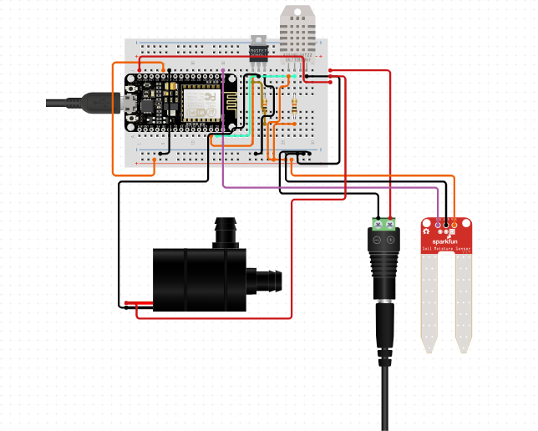

**Features**:

* Smart Agriculture System
* Automatic Irrigation System
* Simple system solves complex task
* User friendly interface
* Cost effective for large scale implementation
* Low power consumption and long self life
* Allows monitoring of all registered plantation areas from anywhere anytime
* GPS based Locating and Tracking System
* Complete updated database for future reference and development
* Water conservation by irrigating only when required
* Automated system for long lasting solution
* Sensor fault detection capability using satellite readings
* Cellular structure and frequency planning to give better coverage
* Room to improvise to higher performance
* Precision agriculture using IoT